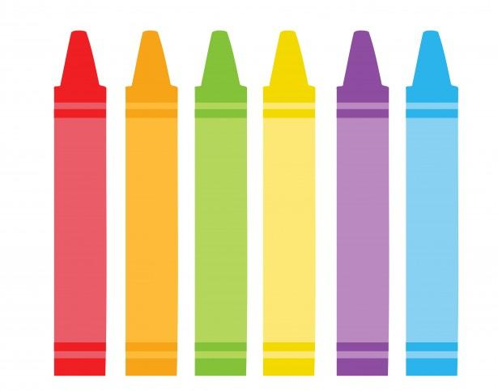**Kindergarten Supply List 2025-2026**

1. Three packs of Crayola Crayons **(24 pack)**
2. Two packs of Elmer’s large glue sticks (**4 pack)**
3. One plastic utility pencil box (length-8inches x width-4.5inches x height-2.5 inches) **(please label with name on the bottom)**
4. An oversized shirt/or smock, for Art Class **(labeled with name)**
5. Two **Plastic** folders (bottom pockets only), one labeled **HOMEWORK (name)** and one labeled **CLASSWORK** **(name). *(no paper folders please)**
6. One pack of sharpened #2 pencils
7. One pack of **black** dry erase markers (**2 or 4 in a pack)**
8. One backpack large enough to carry a lunch box, folder, and belongings   
   (label name inside)
9. One Lunch box (labeled with name)
10. Two boxes of tissues
11. Two packages of baby wipes
12. One roll of paper towels
13. One pack of gallon sized Ziploc bags (zippers preferred)
14. One pack of sandwich sized Ziploc bags (zippers preferred)
15. Two recent pictures of your child
16. One coloring book for Indoor Recess
17. One pair of child safe scissors
18. One container of Clorox/Lysol wipes
19. One clipboard (standard size)
20. One set of headphones (please refrain from sending in earbuds)
21. One 16 oz bottle of hand sanitizer

**\*Please label ALL the pieces of the uniform with first AND last names.**

**When the weather changes, be sure to label hats, gloves/mittens, sweaters, fall/winter coats, scarves, and any additional articles of clothing with your child’s first and last name. Thank you in advance for your help!**